WELCOME LETTER FROM YOUR DIRECTOR OF JUNIOR CLUBS:
Hello Federation Sisters,
As we embark on our two-year journey together, I am honored to welcome you as the 2024-2026 Maryland Director of Junior Clubs. It fills me with great pride and determination to share with you the guiding symbol that will inspire us through these transformative years: the wave. 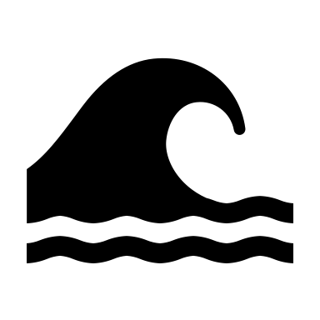
The wave represents our unity and our relentless pursuit of positive change. It signifies our collective strength and our commitment to making a difference. With this powerful symbol, we embrace our motto: "Be the wave of change to shape the future for education."
Education is more than just a commodity; it is the very foundation upon which our communities grow and prosper. It is the cornerstone of progress, the beacon of hope, and the key to unlocking endless opportunities. Our mission is to support and uplift education, ensuring it remains a vital part of our society's fabric.
As we move forward together, I ask each of you to pledge your support for education within your communities. Let us uplift those who seek knowledge and empower the next generation of leaders. We have the power to be the catalysts for change, driving a brighter future for all.
Remember, education is not just about the future—it is our future. And together, united by our shared vision and dedication, we will create waves of impact that will resonate through generations to come.
I am excited to see the incredible achievements we will accomplish together. Let’s embrace the wave and make our mark on the world!
Warm regards,
Amanda Krantz – GFWC MARYLAND DIRECTOR OF JUNIOR CLUBS 2024-2026

